MediGuardian AI: An Agentic and Service-Oriented Framework for Autonomous Healthcare Navigation

PeddiReddy Sree Bhuvaneswari
Department of Computer Science and Engineering, KLH University, Hyderabad, India
sreebhuvaneswaripeddireddy@gmail.com
Bandaru Sai Pranay Choudary
Department of Computer Science and Information Technology, KLH University, Hyderabad, India
saipranaypranay6@gmail.com
Menneni Witty
Department of Computer Science and Information Technology, KLH University, Hyderabad, India
wittymenneni728@gmail.com

Abstract - A Prototype of Healthcare Navigation System for Patient’s Natural Language Queries Using Agentic and Service-Oriented Architecture Essay (Critical Writing)
MediGuardian AI is a prototype healthcare navigation system, which aims to decrease the amount of human-driven actions needed to transition from a patient’s natural language healthcare question into a relevant medical specialization, healthcare service, provider, and appointment action. This system employs an agent-oriented and service-oriented design implemented in Java 21, Spring Boot, Spring Web, Spring Data JPA, Hibernate, PostgreSQL, and a web frontend utilizing HTML, CSS, and JS. A patient query is received in a REST endpoint and processed by an orchestration component, which applies intent, specialty, service, and urgency logic. The result is combined with provider and service records stored in PostgreSQL to form a structured response, which contains the identified specialization, service, urgency, available doctors, services, and a next action. The prototype also provides appointment management and persistence. Notably, unlike systems intended for the diagnosis of disease, the MediGuardian AI is a navigation and coordination layer, and does not replace clinical judgment. Testing is performed to verify the functional behavior of the prototype in several representative navigation and appointment scenarios. The paper presents the architecture, implementation, database model, API design, workflow, testing approach, limitations, and future extensions of the prototype.
Index Terms—Healthcare navigation, agentic systems, service-oriented architecture, Spring Boot, REST API, PostgreSQL, appointment management, healthcare information systems.

I. INTRODUCTION -
Healthcare information is often fragmented across sources and patients may express needs in everyday language compared to the terminology of healthcare providers. A request like an injury of the shoulder, a problem involving teeth, a complaint of the eye, or a chronic headache may involve deciding on an appropriate specialization, matching it to a service, finding a suitable provider, and completing an appointment workflow. This is a practical navigation task even when the underlying information of providers is already available.
Recent work has explored large language models and agentic systems as interfaces for healthcare information and decision support. Thirunavukarasu et al. have reviewed opportunities and risks of large language models in medicine emphasizing their broad language capabilities but also the need for caution in healthcare contexts [1]. Qiu et al. have described LLM-based agentic systems as systems which can process information, plan, interact with tools, and collaborate opening opportunities for automating healthcare workflows [2]. Liu et al. have demonstrated a multi-agent self-triage framework which combines language-model interaction with medical flowcharts [3].
MediGuardian AI addresses a narrower and implementation-focused problem scope. Instead of diagnosing a disease the prototype converts a natural-language healthcare request into a structured navigation result. The system identifies a specialization and matches it to a service estimating a simple urgency category using predefined rules while retrieving relevant doctors and services providing a next action for appointment booking. The design connects agent-style processing with a service-oriented backend and a persistent healthcare database.
The contributions of this work are: (1) a working healthcare navigation prototype implemented using Spring Boot and PostgreSQL; (2) an orchestration model which combines intent, specialty, service, and urgency processing; (3) integration of doctor, patient, healthcare-service, hospital, and appointment data; (4) a REST API for structured navigation responses; and (5) an implementation-focused evaluation using functional test scenarios
.

II. RELATED WORK
Artificial intelligence in healthcare has evolved from the paradigm of task-specific decision support systems to systems where the user is engaged in a natural language discourse with an AI assistant. While large language models have showcased remarkable language understanding and generation abilities, healthcare applications call for a careful consideration of reliability, interpretability, safety, and evaluation. Agentic systems represent one possible approach, as they implement the principle of using a system where the user’s input can be processed, tools utilized, internal state maintained, and complex sets of actions taken.
The contribution of Liu et al. in the 2026 article relates to developing a multi-agent approach to self-triage based on medical flowcharts. The paper describes how retrieval, decision, and conversation agents work together in concert with medical flowcharts to implement self-triage. The authors highlight their evaluation methodology, which utilized synthetic conversations, and the importance of using structured, auditable guidance. MediGuardian AI is similar to this work in its application of language-based processing and interaction with users, but it is focused on a different set of problems. While MediGuardian AI also utilizes a multi-agent architecture, it is designed to assist in healthcare-related tasks, as opposed to performing self-triage and medical diagnosis.
Finally, service-oriented approaches to clinical decision support can also be relevant to this contribution. The work of Wright and Sittig, SANDS: A Service-Oriented Architecture for Clinical Decision Support, is pertinent to the topic as it describes the general principles for developing such systems. By delineating considerations for building SANDS, a service-oriented clinical decision support system, the authors outline a series of steps necessary for implementing an architecture that supports the exchange of information between distributed agencies. MediGuardian AI’s design is similar to SANDS in a limited capacity: both systems separate request handling, orchestration, and repository/persistence components. However, MediGuardian AI is a prototype that only processes requests within a limited scope and does not operate as a part of a larger healthcare information system.
Reference Description Connection to MediGuardian AI
Reference | Main focus | Relation to MediGuardian AI
[1] | Large language models in medicine | Decision-making This work provides context and motivation for exploring agentic systems for healthcare
[2] | LLM-based agentic systems | Paper provides conceptual basis for MediGuardian AI
[3] | Multi-agent self-triage with medical flowcharts | Similar approach, but applied to a different problem
[4] | Service-oriented clinical decision support | Motivates the development of MediGuardian AI

III. RESEARCH GAP AND PROBLEM STATEMENT
Existing healthcare AI research considers conversational systems, clinical decision support, self-triage, and agentic workflows, but there is a practical student-scale healthcare application that can target a different layer of the problem: navigation between a patient's free-text request and operational healthcare resources. The gap being considered in this work is the integration of patient intent interpretation, specialization mapping, service identification, simple urgency handling, provider discovery, and appointment management within one service-oriented prototype.
The problem being addressed is therefore as follows: Given a patient's natural-language healthcare request and patient identifier, the system should determine an appropriate healthcare specialization and service, assign a non-diagnostic urgency category, retrieve relevant provider and service information from a structured database, and return an actionable navigation response, and also support appointment persistence after a provider and time have been selected.

IV. PROPOSED SYSTEM
MediGuardian AI consists of a web interaction layer, a REST API layer, an agent-oriented navigation layer, a repository/data layer, and an appointment management layer. The architecture is designed in a modular manner so that the rule-based intent component can later be replaced by or enhanced with more sophisticated natural-language models, without redesigning the entire database and API.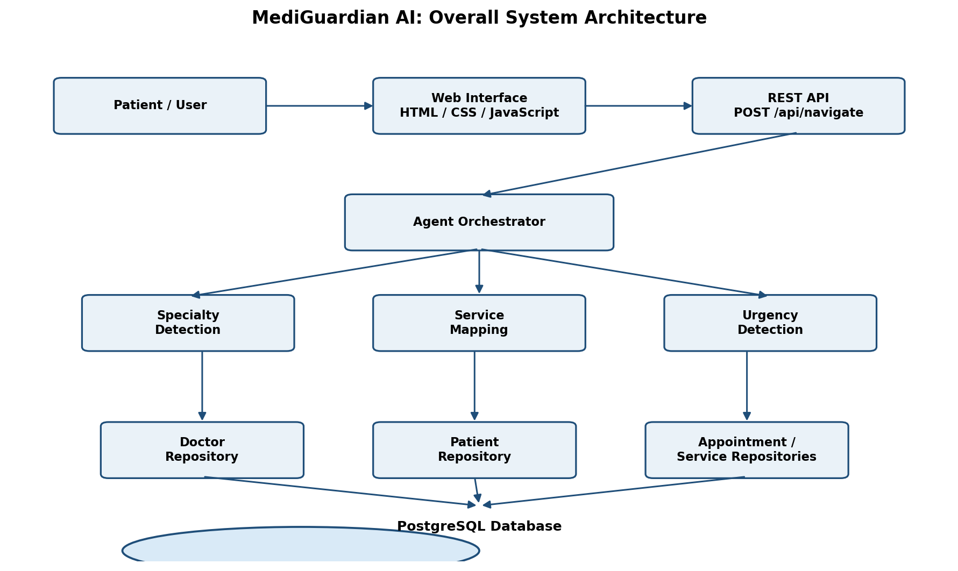
Fig. 1. Overall architecture of the MediGuardian AI healthcare navigation system.
The patient sends a query either via the frontend or the directly available REST API. The NavigatorController receives a navigation request consisting of patientId and query. The request is passed on to an AgentOrchestrator that orchestrates the interpretation and lookup steps for resources. The resulting object consists of the original request, specialization, service, urgency, doctors, services, and nextAction.

V. METHODOLOGY

A. Input Processing

The navigation request is captured as a smaller request object that contains a patient identifier and a free-text query. The controller checks the request shape and passes the processing to the orchestrator to decouple HTTP logic from the navigation processing.

B. Intent and Specialization Detection

The prototype currently uses deterministic keyword-based rules. For instance, the words related to tooth, dental, and gum are mapped to Dentistry; eye and vision-related phrases are mapped to Ophthalmology; skin, rash, and acne-related terms are mapped to Dermatology; heart and chest-pain related terms are mapped to Cardiology; headache and migraine-related terms are mapped to Neurology; and shoulder-injury requests are mapped to Orthopedician with Orthopedic Consultation as a service. Unmatched terms are delegated to General Medicine.

C. Service Mapping

Once a specialization is detected, a corresponding service label is created. For instance, the available services include Dental Consultation, Eye Examination, Skin Consultation, Cardiology Consultation, Neurology Consultation, Orthopedic Consultation, and General Consultation.

D. Urgency Detection

The prototype has a rudimentary rule-based urgency detection mechanism. Explicit emergency phrases such as severe chest pain, difficulty breathing, unconsciousness, or heavy bleeding are mapped to EMERGENCY. The terms such as severe, persistent, or high fever are labeled HIGH; while other requests are filed under ROUTINE. This is a demonstration navigation aid and should not be used for triage or medical diagnosis.

E. Resource Retrieval

Once a specialization is detected, repository components can retrieve related doctor and healthcare-service records. The Doctor entity stores the provider details such as name, specialization, hospital, location, consultation fee, and available time. The Healthcare-service records contain the service and cost details.

F. Appointment Management

The appointments are stored with the patientId, doctorId, appointmentDate, appointmentTime, and status. The appointment controller creates appointment records and uses a confirmation status when an appointment is accepted. The prototype considers the declared availability of the doctor when the appointment selection is implemented.

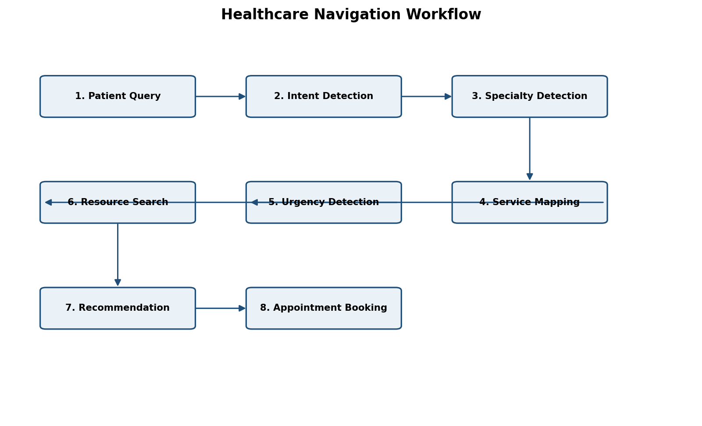
Fig. 2. Healthcare navigation workflow from patient query to appointment booking.

VI. AGENT ARCHITECTURE
The term agent in this prototype refers to a modular processing component, orchestrated by an orchestrator. The current implementation is not a large language model agent and should not be described as such. The architecture is designed in such a way that the navigation logic is decoupled into functions that can later be augmented with machine-learning or retrieval-augmented components.

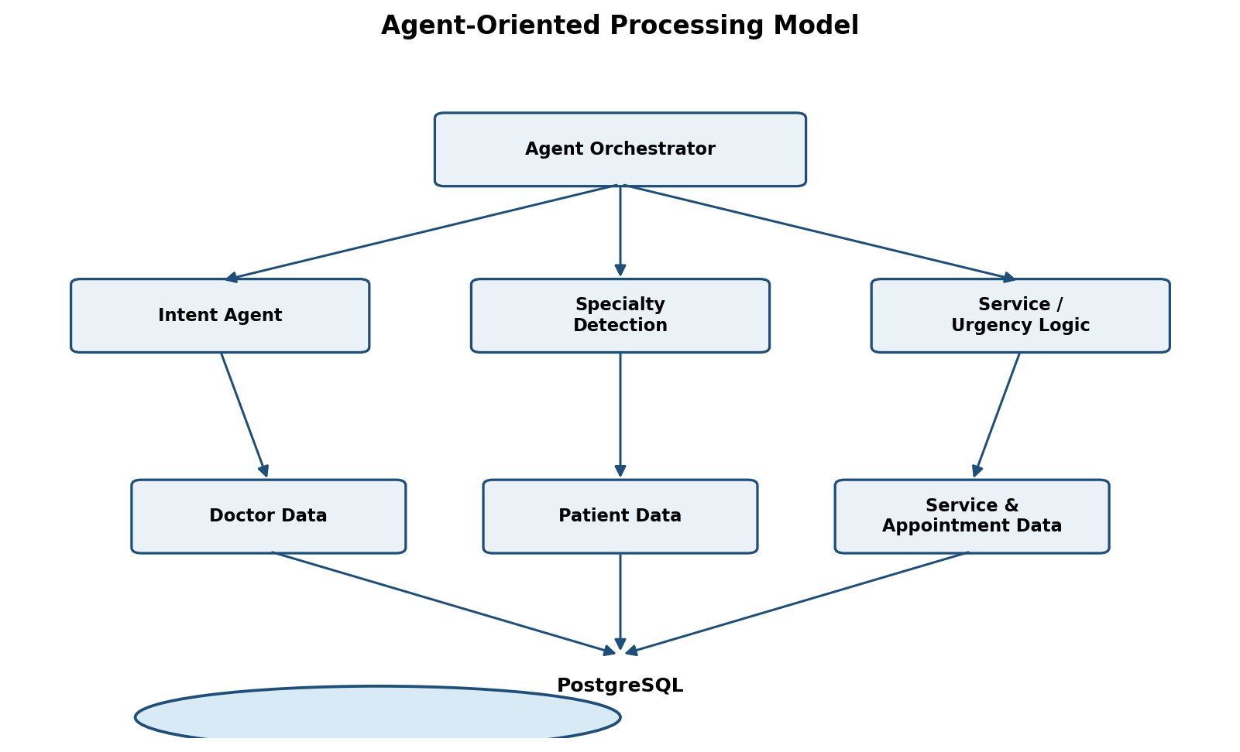

Fig. 3. Agent-oriented processing model used by MediGuardian AI.

The AgentOrchestrator acts as the central coordinator. The IntentAgent performs specialty, service and urgency detection. Repository components then bind the interpreted request to persistent data. This decoupling improves maintainability, as changes to the intent rules do not require rewriting the controller or database layer.
.

VII. DATABASE DESIGN
The back end is built with PostgreSQL database and uses Spring Data JPA and Hibernate to enable the object-relational persistence mechanism. The main entities are Patient, Doctor, Hospital, HealthcareService, and Appointment. Figures below represent the minimum data required by the prototype to store essential information connecting patients, providers, healthcare service, and appointments.
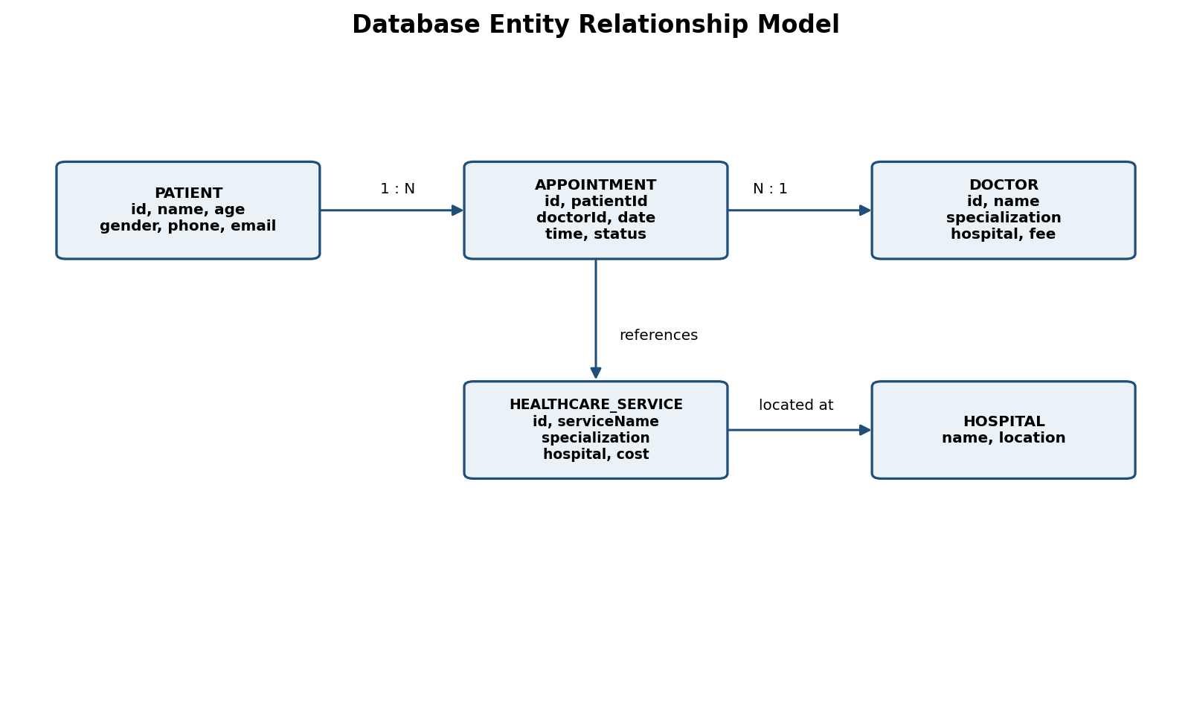
Fig. 4. Entity relationship model of the MediGuardian database.
Entity | Important fields | Purpose
Patient | id, name, age, gender, phone, email | Stores patient profile information.
Doctor | id, name, specialization, hospital, location, consultationFee, availableTime | Stores provider information used for navigation.
Hospital | name, location | Associates providers and services with healthcare facilities.
HealthcareService | id, serviceName, specialization, hospital, cost | Represents services that can be recommended.
Appointment | id, patientId, doctorId, appointmentDate, appointmentTime, status | Stores appointment selections and state.

VIII. API DESIGN AND IMPLEMENTATION
The main navigate end point is POST /api/navigate where the request contains patientId and query. The controller passes the request to the AgentOrchestrator and responds with a structured map that contains the result of the navigation, including specialization, service, urgency, doctors, services, and nextAction.
API | Method | Input | Output
/api/navigate | POST | patientId, query | specialization, service, urgency, doctors, services, nextAction
/api/appointments | POST | patientId, doctorId, date, time, status | Created appointment
/api/appointments | GET | None | List of appointments

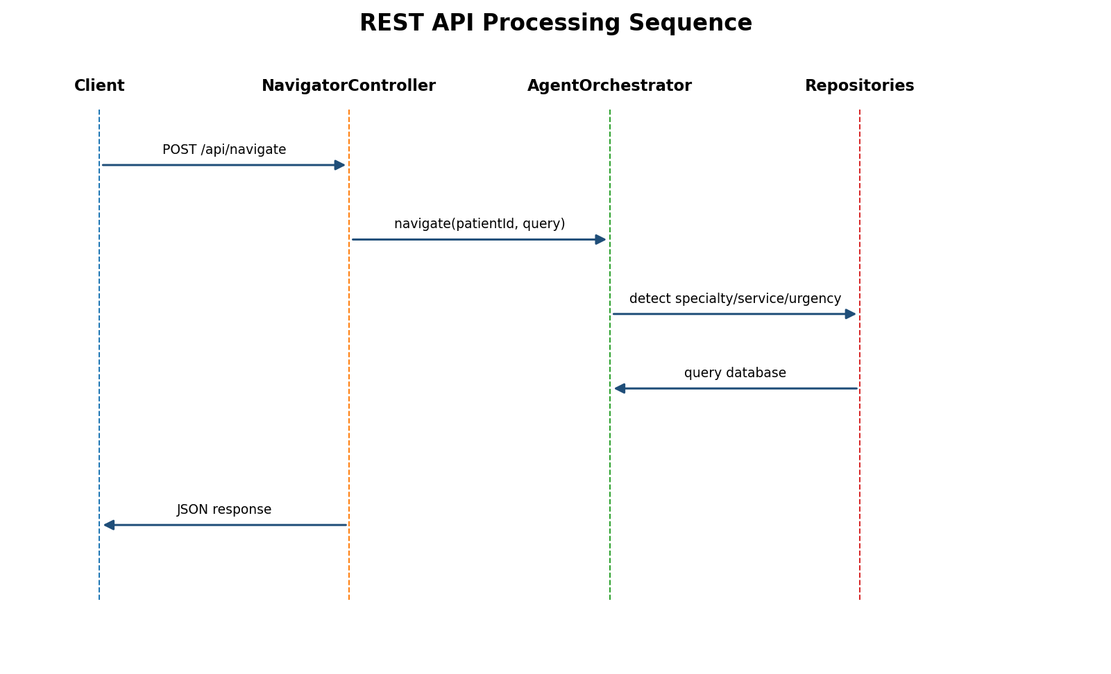
Fig. 5. REST API processing sequence for a navigation request.
The project is implemented using Java 21, Spring Boot, Spring Web, Spring Data JPA, Hibernate, PostgreSQL 13, pgAdmin, HTML, CSS, JavaScript, and Postman. Spring Web is used to expose REST endpoints, and Spring Data JPA is used to abstract database operations with Hibernate as the persistence framework and PostgreSQL 13 as the relational database.

IX. EXPERIMENTAL SETUP AND FUNCTIONAL TESTING
The prototype was evaluated using test cases representative of healthcare-navigation inputs and appointment operations. The evaluation was performed by executing REST requests via Postman and inspecting JSON results, and pgAdmin was used to inspect persisted PostgreSQL records. The evaluation is pragmatic and not representative of a clinical validation study. Below are some representative test cases.
Test Case | Input / Operation | Expected result | Observed outcome
TC01 | Shoulder injury; request for orthopedician | Orthopedician + Orthopedic Consultation | Passed
TC02 | Tooth or dental problem | Dentistry + Dental Consultation | Passed when matching rule is used
TC03 | Eye or vision problem | Ophthalmology + Eye Examination | Passed when matching rule is used
TC04 | Severe chest pain | EMERGENCY category | Passed when exact emergency phrase is detected
TC05 | Appointment creation | Appointment stored with confirmation status | Passed
TC06 | Appointment retrieval | Stored appointment returned through GET endpoint | Passed

A representative navigation response for the implemented shoulder-injury scenario contains the specialization Orthopedician, the service Orthopedic Consultation, the urgency category ROUTINE, matching doctor and service records, and the next action to select a doctor and book an appointment. A representative appointment test used the date 24-09-2026 and time 4:00 PM and returned a CONFIRMED appointment record. These observations demonstrate end-to-end persistence for the tested prototype scenario. They should not be generalized into clinical performance or production-level availability claims.

X. RESULTS AND DISCUSSION

The primary outcome of the prototype is a working navigation pipeline from natural-language inquiries to actionable healthcare resources. The system showcases how a backend can be composed of simple intent rules, repository queries, and appointment persistence without requiring a clinical AI model.

The design also allows for a smooth migration path. A future IntentAgent could apply a language model or retrieval-based classifier that has been validated on a larger set of patient inquiries. A service registry pattern can substitute hard-coded request/response mappings, and provider availability can be delegated to a scheduling service. All of these enhancements can be implemented while retaining the REST controller, repository abstraction, and persistence layers.

No claims of numerical accuracy, clinical sensitivity, response-time benchmarks, or patient outcome improvements are made by this paper, as the prototype evaluation does not establish such metrics. Further experimental work must define a representative data set, a clinical or expert annotation standard, and reproducible performance assessment before quantitative outcome claims can be made.

XI. NOVELTY AND PRACTICAL CONTRIBUTION

The contribution of MediGuardian AI is primarily architectural and implementation-focused. The combined prototype demonstrates five capabilities within a single workflow: handling of patient intent, specialization/service mapping, simple urgency categorization, healthcare resource discovery, and appointment management. The novelty of the work should therefore be framed in terms of bundling of functionality within a compact service-oriented navigation prototype, instead of agentic healthcare systems as a whole.

The system is also designed to separate navigation logic from persistent healthcare data, thus enabling the same backend to power a web client, Postman-based testing, and future mobile or voice interfaces.

XII. LIMITATIONS AND ETHICAL CONSIDERATIONS
The current prototype has several limitations and ethical considerations. First, the intent and urgency detection are rule-based and therefore rely on predefined keywords. Second, the database contains prototype provider and service information, rather than a continually synchronized healthcare directory

Third, the system does not perform diagnosis or individualized clinical treatment planning. Fourth, provider availability is simplified and does not represent a live hospital scheduling system. Fifth, the prototype does not yet implement full authentication, authorization, encryption, audit logging, or interoperability with hospital information systems.

XIV. CONCLUSION
The MediGuardian AI showcases an innovative healthcare navigation approach, in which the natural language request of a patient is converted into an appropriate recommendation and appointment scheduling. The developed prototype utilizes Spring Boot REST services, the agent-style processing modules, Spring Data JPA, PostgreSQL database, healthcare resources repository and appointment management. The proof-of-concept results presented in the paper demonstrate that the implemented prototype is capable of routing example requests towards appropriate specializations and services, as well as storing the appointment details in a database. It is important to note that the prototype is designed as a limited concept, which is aimed to demonstrate the navigation process, but not to provide actual medical advice. The prototype could be expanded upon by implementing additional modules, which would allow for more sophisticated language understanding, healthcare-related dialogue management, repository of providers with trustworthiness assessment, and evidence-based evaluation methodology.

PROJECT FIGURES TO INSERT BEFORE SUBMISSION
The following items should be replaced with screenshots from the student's actual working system. They are intentionally left as placeholders so that no fabricated interface or database evidence is presented.

Screenshot A
INSERT YOUR ACTUAL PROJECT SCREENSHOT HERE
MediGuardian frontend / user interface

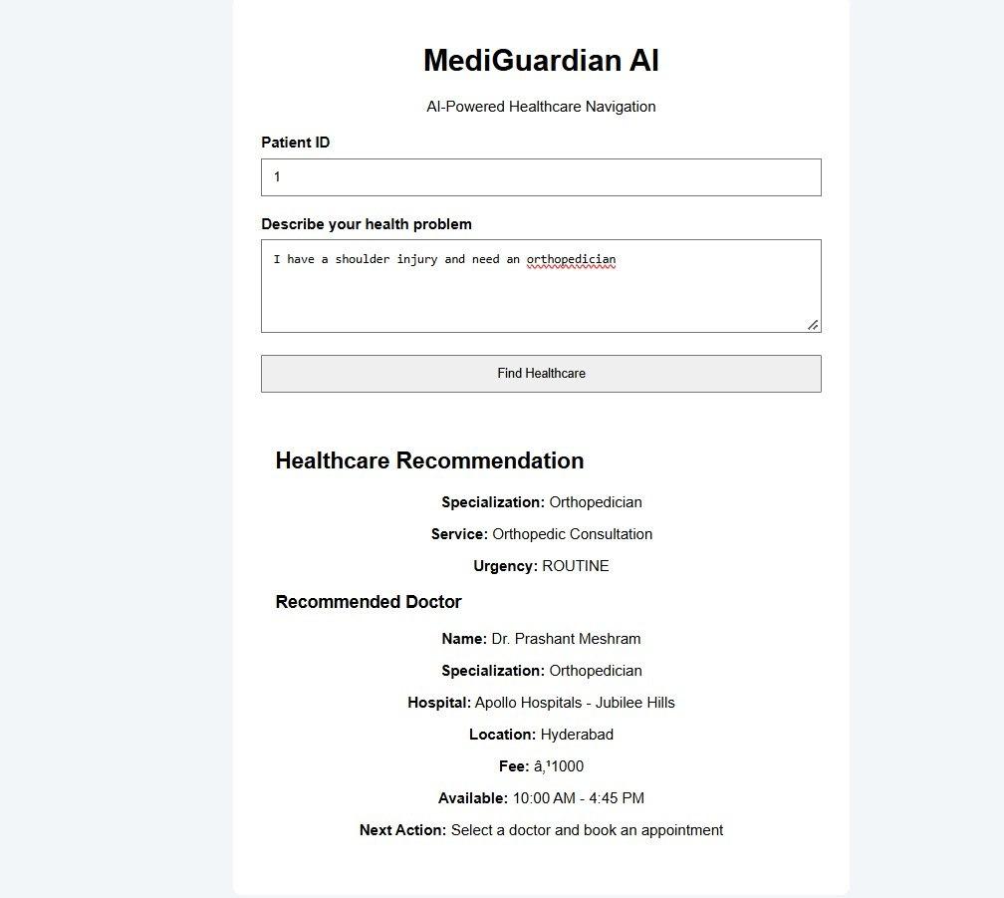

Screenshot B
INSERT YOUR ACTUAL PROJECT SCREENSHOT HERE
Postman request to POST /api/navigate

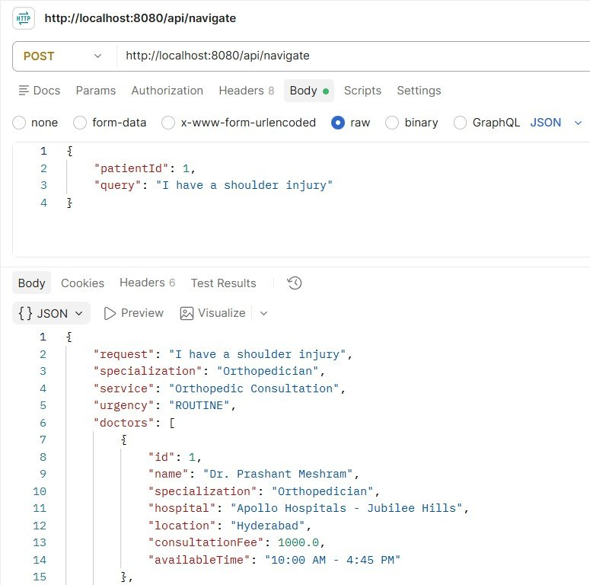

Screenshot C
INSERT YOUR ACTUAL PROJECT SCREENSHOT HERE
Postman JSON response for the shoulder-injury / orthopedician test

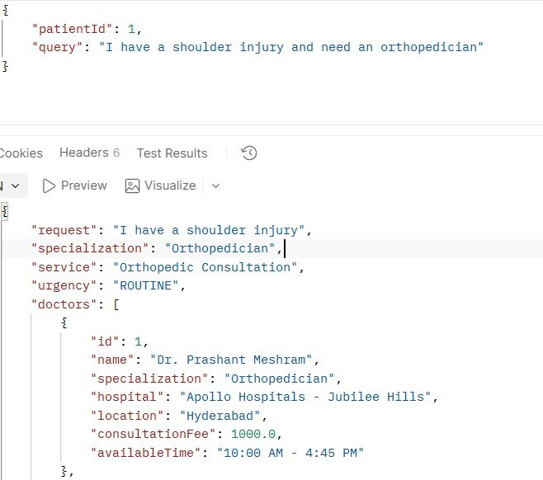

Screenshot D
INSERT YOUR ACTUAL PROJECT SCREENSHOT HERE
Appointment creation response showing date, time, and status

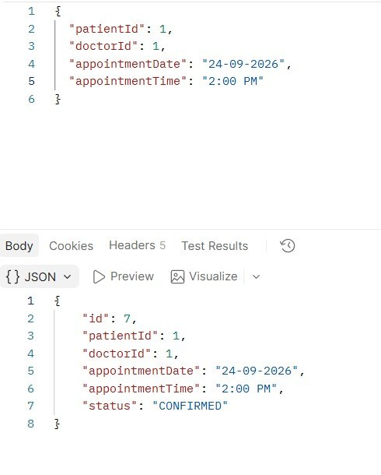

REFERENCES
[1] A. J. Thirunavukarasu, D. S. J. Ting, K. Elangovan, L. Gutierrez, T. F. Tan, and D. S. W. Ting, “Large language models in medicine,” Nature Medicine , vol. 29, pp. 1930-1940, 2023, doi: 10.1038/s41591-023-02448-8.
[2] J. Qiu, K. Lam, G. Li, A. Acharya, T. Y. Wong, A. Darzi, W. Yuan, and E. J. Topol, “LLM-based agentic systems in medicine and healthcare,” Nature Machine Intelligence , vol. 6, pp. 1418-1420, 2024, doi: 10.1038/s42256-024-00944-1.
[3] Y. Liu, S. Yu, H. Jin, J. Wen, A. Qian, T. Lee, M. Ramsis, G. W. Choi, L. Qin, X. Liu, and E. J. Wang, “A multi-agent framework combining large language models with medical flowcharts for self-triage,” Nature Health , vol. 1, pp. 840-849, 2026, doi: 10.1038/s44360-026-00112-2.
[4] A. Wright and D. F. Sittig, “SANDS: A service-oriented architecture for clinical decision support in a National Health Information Network,” Journal of Biomedical Informatics , vol. 41, no. 6, pp. 962-981, 2008, doi: 10.1016/j.jbi.2008.03.001.
[5] J. Hager et al., “Evaluation and mitigation of the limitations of large language models in clinical decision-making,” Nature Medicine , 2024, doi: 10.1038/s41591-024-03097-1.
[6] M. Bedi et al., “Testing and evaluation of health care applications of large language models: A systematic review,” JAMA , 2025, doi: 10.1001/jama.2024.21700.
[7] A. Ouanes and M. Farhah, “Effectiveness of artificial intelligence in clinical decision support systems and care delivery,” Journal of Medical Systems , 2024, doi: 10.1007/s10916-024-02098-4.
[8] J. Gomez-Cabello et al., “Artificial-intelligence-based clinical decision support systems in primary care: A scoping review of current clinical implementations,” European Journal of Investigation in Health, Psychology and Education , vol. 14, no. 3, 2024.
[9] J. Peek et al., “Bridging the gap: Challenges and strategies for the implementation of artificial intelligence-based clinical decision support systems in clinical practice,” Yearbook of Medical Informatics , 2024.
[10] M. Busch et al., “Current applications and challenges in large language models for patient care: A systematic review,” Communications Medicine , 2025, doi: 10.1038/s43856-024-00717-2.
[11] A. Moulaei et al., “Generative artificial intelligence in healthcare: A scoping review on benefits, challenges and applications,” International Journal of Medical Informatics , 2024, doi: 10.1016/j.ijmedinf.2024.105474.
[12] HL7 International, “FHIR Overview,” FHIR Release 5, 2023.

